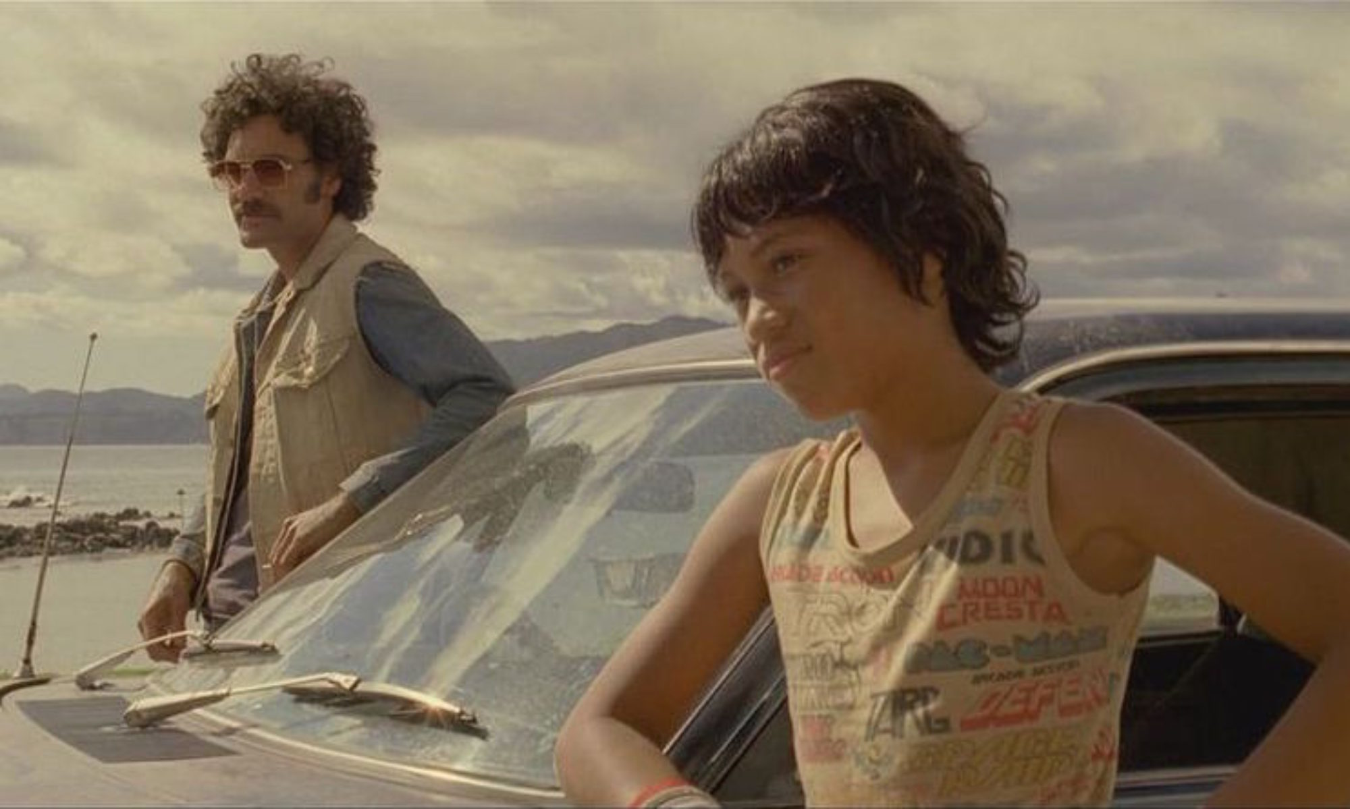

BILDUNGSROMAN: FORM AND TRANSFORMATIONS

CONFERENCE PROGRAMME

IMPORTANT INFORMATION

Emergency Numbers:
University Security Service: 93513333
Melissa Hardie (convenor): 0416125116
Wifi: UniSydney-Guest
Username BRoman
Password 46358660

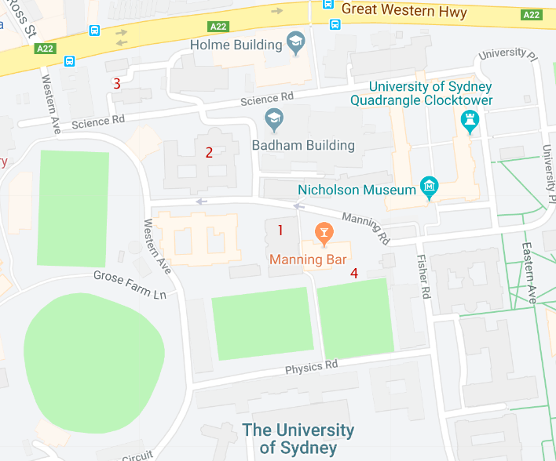

VENUES:
- Education Building (Sessions 1 & 2, Registration, Thurs and Fri morning and afternoon tea, lunch)
- John Woolley Building (Friday drinks)
- Social Sciences Building (Keynotes and Thursday drinks)
- Manning BBQ Area (Weekend morning and afternoon tea, lunch)

THURSDAY 22 NOVEMBER, 2018

10.00-12:30 Registration (Education Staff common Room 401)

12.00-12:45 Lunch (Education Staff common Room 401)

1.00-2.30

Session 1 (Education Lecture Room 351): Conceptualising the Bildungsroman
Chair: Katie Trumpener
Aleksander Stevic, Qatar: ‘The Trouble with Bildung’
Adam Hearman, UWA: ‘Digression through error: On the indirection of the aesthetic in Goethe’s Wilhelm Meister’
Matthew Taft, Duke: ‘The Bildungsroman: form or method’

Session 2 (Education Lecture Room 424): Coupling and the Bildungsroman
Chair: Guy Davidson
Lisa O’Connell, Queensland: ‘Bildungsroman and Marriage Plot: a happy couple?’
Matthew Clarke, Sydney: ‘Beyond Gay: Denton Welch’s In Youth Is Pleasure”
Elli Kyrmanidou, Ludwig Maximillian University, Munich: ‘The Intersex Bildungsroman: A Contemporary Approach’

2.30-3.15 coffee break (Education Staff common Room 401)

3.15-4.45

Session 1 (Education Lecture Room 351): Australian Bildung
Chair: John Frow
Ken Gelder & Rachael Weaver, Melbourne: ‘The Australian Kangaroo Hunt Novel (1830-1858) as Bildungsroman’
Brigid Rooney, Sydney: ‘Expatriate visions: Australian literary suburbia and the Bildungsroman’

Session 2 (Education Lecture Room 424): Girls’ Stories
Chair: Isabelle Hesse
Honni Van Rijswijk, UTS: Law’s Bildungsroman and the Girl: Genre and gender in the interpretation of violence
Kate Douglas, Flinders ‘“With this first cigarette, I kissed childhood goodbye”: Marjane Satrapi’s Persepolis on Adolescence’
Bec Kavanagh and Simmone Howell, LaTrobe: ‘The female Bildungsroman: liberating the adolescent female protagonist through memoir’

5-6.30

Acknowledgement of Country: Evelyn Araluen (Sydney)

Keynote 1 (Social Sciences Building Lecture Theatre 200):

Katie Trumpener, Emily Sanford Professor of Comparative Literature and English, Yale
‘Actors, Puppets, Girls: Little Women and the Collective Bildungsroman’

6.30-8.00 Opening Drinks: Social Sciences Building Foyer.

FRIDAY 23 NOVEMBER, 2018

8.45-10.15

Session 1 (Education Lecture Room 351): Fanny Burney and the Bildungsroman
Chair: Vanessa Smith
Alexander Creighton, Harvard: ‘Bildung Temporalities in Frances Burney’
Sara Crouch, Sydney: ‘‘The Last Touches of the Picture’: the formation of feminine character in Frances Burney’s Camilla (1796)’
Megan Nash, Sydney: ‘Sentimental Miseducation: The Coming-of-Age of a Genre’

Session 2 (Education Lecture Room 424): American Bildungsromane
Chair: Paul Giles
Bavani Moodley, Sydney: 'Discursive Materialities: Formations of the Self from Tristram Shandy to Huckleberry Finn'
Setsuko Ohno, Kyushu Institute of Technology: ‘Connection or Disconnection: a way out of social contamination in American college novels’
Pardis Dabashi, Boston University: ‘Nella Goes to the Movies: The End of the Bildungsroman and the Coming of Classical Film

10.15-11 coffee (Education Staff common Room 401)

11.00-12.30

Session 1 (Education Lecture Room 351): Regency Bildungsromane
Chair: Lisa O’Connell
Sarah Ailwood, University of Canberra: ‘Jane Austen, romantic love and the male Bildungsroman’
Lydia Verschaffelt, Victoria University of Wellington: ‘Mr Woodhouse and Limits of the Female Bildungsroman Framework’
Olivia Murphy, Sydney: ‘Natural sequels to unnatural beginnings: bad girls and the Romantic Bildungsroman’

Session 2 (Education Lecture Room 424): Recent British Bildungsromane
Chair: Nancy Armstrong
Ned Curthoys, UWA: ‘The affinity of the Bildungsroman with Unreliable Narrative’
Lynda Ng, Sydney: ‘Fixing to Die: Kazuo Ishiguro’s Reinvention of the Bildungsroman’
Michael Allen, Harvard: ‘The Thatcherite Bildungsroman’

12.30- 1.30 Lunch (Education Staff common Room 401)

1.30-3.00

Session 1 (Education Lecture Room 351): Serial Bildungsroman
Chair: Melissa Hardie
Michael Ormsbee, Rochester: ‘Personal Growth, National Pride: The Mythos of Bildungsroman in Jane Eyre and The Great Queen Seondeok’
Monique Rooney, ANU: ‘Only Mediate: the Mere Interest of Interbrow in Kenneth Lonergan’s Margaret (2011) and Howards End (2017)’
Blythe Worthy, Sydney: Sites of Trauma: Imagery Rescripting in the Television Work of Jane Campion

Session 2 (Education Lecture Room 424): New literatures, new Bildung?
Chair: Ken Gelder
Michael Griffiths, Wollongong: ‘Otherwise than Literal: The Arrest of Allegory in a Postcolonial Bildungsroman’
Meltem Gurle, Trinity College Dublin: ‘The Return of Children: A Comparative Study of Contemporary Turkish and Irish Novels’
Jean-François Vernay: ‘Gazing Inward and Outward: (Trans)formation in C.J. Koch’s Bildungsroman Protagonists and Readers

3.00-3.45 coffee break (Education Staff common Room 401)

3.45-5.15

Session 1 (Education Lecture Room 351): ‘Autobiographical’ Bildungsromane
Chair: Vanessa Smith
Benjamin Hoffman, Ohio State: ‘A Poetics of Confusion: Casanova’s Story of My Life as Bildungsroman’
Stephanie Last, Sydney: ‘Just a “’umble” servant? Re-evaluating the villain of Charles Dickens’s David Copperfield as a double of the protagonist and subject of a parallel Bildungsroman plot’
Eri Satoh, Kobe College: ‘Fantastic and Realistic “Wandering” in Female Bildungsromans: George Eliot’s The Mill on the Floss and Christina Rossetti’s Speaking Likenesses’

Session 2 (Education Lecture Room 424): Future Fiction and the Bildungsroman
Chair: Melissa Hardie
Stuart Molloy, UWA: ‘“But now as I end this story, brothers, I am not young, not no longer…”: The ambivalence of a coming-of-age logic in Anthony Burgess’ A Clockwork Orange’
Anthony D’Agostino, Fordham: ‘From Jane Eyre to Jean Grey: Marvel Comics’ The Uncanny X-Men: The Dark Phoenix Saga as Queer-Feminist Bildungsroman’
Ashley Maher, Sydney: ‘Memoirs of a Spacewoman: Naomi Mitchison and Interspecies, Intergalactic Educations’

5.30- 7.00 Keynote 2 (Social Sciences Building Lecture Theatre 200):

Joseph Litvak, Professor of English, Tufts
‘Black Comedy and the Bildungsroman: Fran Ross’s Oreo’

7.00-8.00 drinks, Woolley Common Room

Saturday 24 November, 2018

8.45-10.15

Session 1 (Education Lecture Room 351): Victorian Bildungsromane
Chair: Vanessa Smith
Jessica Valdez, Hong Kong: ‘“Bad Infinity,” Newspapers, and the Victorian Novel’
Philippa Janu, Sydney: ‘“Tutored by Experience”: The Formation of the Governess in Anne Brontë’s Agnes Grey’

Session 2 (Education Lecture Room 424): The Bildungsroman and YA fiction
Chair: Brigid Rooney
Evan Lawless, Curtin, ‘Narrating Twinks: Contemporary Young Adult Coming-of-Age Narratives and Their Relation to the Foundling’
Isabelle Hesse, Sydney: ‘The Contemporary Bildungsroman as a Didactic Tool: Engaging with Israel/Palestine in Young Adult Fiction Israel/Palestine YA fiction’
Samantha Poulos, Sydney: ‘“A fire that burns that bright is not meant to last” – Tris Prior and death of the hero’

10.15-11.00 coffee

Saturday 11.00-12.30

Session 1 (Education Lecture Room 351): Televisual Bildung
Chair: Monique Rooney
Guy Davidson, Wollongong: ‘Ineducable: Advertising Fictions on TV’
Stella Ktenas, Sydney: ‘Bildungsroman and narratology in The Simpsons episode “Lisa the Vegetarian”’
Kate Lilley, Sydney: ‘Walter White, Walt Whitman’

Session 2 (Education Lecture Room 424): The Bildungsroman and Twentieth-century politics
Chair: John Frow
Boel Hackman, Stockholm: ‘Rhetorical Strategies in Ulla Bjerne’s Botad oskuld/Innocence Remedied (1961)’
Yi Zheng, Sydney: ‘The Bildungsroman of an Absolute Socialist Artist: Fu Lei’s Family letters 1954-1966’

12.30- 1.30 Lunch

Saturday 1.30-3.00

Session 1 (Education Lecture Room 351): ‘The 19th-century female Bildungsroman’
Chair: Vanessa Smith
Isabelle Butler, LaTrobe: ‘Nature, environment, and the construction of identity in Jane Eyre and My Brilliant Career’

Sophie Frazer, Sydney: ‘“The orb of my life is not to be so rounded”: The ambivalence of the Bildungsroman in Charlotte Brontë’s Villette’

Session 2 (Education Lecture Room 424): The Bildungsroman and history
Chair: John Frow
Paul Giles, Sydney: ‘The Metabildungsroman: Thomas Mann’s Joseph and his Brothers’
Manuel Clemens, ANU: ‘Why We Took the Car:Wolfgang Herrndorf’s Tschick Proposes the Beginning of a Bildungsroman‘

3.00-3.45 coffee break

Saturday 3.45-5.15

Session 1 (Education Lecture Room 351): Melancholia and the Bildungsroman
Chair: Ashley Maher
Eleanor Rowe, Brown: ‘Jean, Genre, Gender: Critique and Comedy in Rhys’s Paris Novels’
Rebekah Galbraith, Victoria University Wellington: ‘The Schizoid Self: Narrative Strategies in Sylvia Plath’s The Bell Jar’

Session 2 (Education Lecture Room 424): Contemporary Bildungsroman
Chair: Melissa Hardie
Agata Lagiewka, National University of Ireland: ‘Lucky Broken Girl: Growing up with Cuban Island Dreams in New York City’
Ella Collins-White, Sydney: ‘Breaking the Mould: “I am obliterated./ I am found”’
Yuki Namiki, Tokyo Kasei University: ‘It’s a Wise Child who Knows His Own Father: The Figure of the American Family in The Last Samurai and Extremely Loud and Incredibly Close’

5.30- 7.00 Keynote 3 (Social Sciences Building Lecture Theatre 200):

Nancy Armstrong, Gilbert, Louis, and Edward Lehrman Professor of English, Duke.
‘Why the bildungsroman no longer works.’

8.00 conference dinner (Thai Potong, 294 King St, Newtown)

SundayNovember 25, 2018

9.00-10.30

Session 1 (Education Lecture Room 351): Bildung Economies
Chair: Joseph Litvak
Dan Dixon, Sydney: ‘The art of conversation in Rachel Cusk’s Transit trilogy’
Alexander Howard, Sydney: ‘Wild Mood Swings: The Bildungsroman in the Age of Austerity’
Melissa Hardie, Sydney: ‘Bad Bildung: Ivana Trump’s For Love Alone’

10.30-11.15 coffee break

Sunday 11.15-12.45

Session 1 (Education Lecture Room 351): Fantasy and the Bildungsroman
Chair: Melissa Hardie
Jennifer Nicholson, Sydney: ’Translating Miyazaki: Monolingualism, Mononoke-hime, and other Monsters’
Tiffany Basili, Sydney: ‘“Never go that way!”: Fighting to find the balance between responsibility and independence on the path to womanhood in Neil Jordan’s A Company of Wolves, and Jim Henson’s Labyrinth.’

Session 2 (Education Lecture Room 424): Literary Transformations of the Classical Bildungsroman
Chair: John Frow
Elizabeth King, UNSW: ‘The Origins of the Author-Character: Representations of writers in the Bildungsroman’
John Attridge, UNSW: ‘Dumb knowledge in Karl Ove Knausgaard’s My Struggle’
Tamlyn Avery, ACU/UNSW: ‘After Bildung: Towards a theory of the Halbbildungsroman’

THANK YOU
This conference has been supported by funding from the School of Literature, Art and Media, and the Faculty of Arts and Social Sciences, University of Sydney.
Cover image: from Taika Waititi’s Boy (2010).

Contact details for speakers and chairs:
Ailwood, Sarah: Sarah.Ailwood@canberra.edu.au
Allen, Michael: michaelpatrickallen@g.harvard.edu
Armstrong, Nancy: n.b.armstrong@duke.edu
Attridge, John: j.attridge@unsw.edu.au
Avery, Tamlyn: tamlyn.avery@unsw.edu.au

Basili, Tiffany: tbas6170@uni.sydney.edu.au
Butler, Isabelle: 16118809@students.latrobe.edu.au

Clarke, Matthew: mcla6543@uni.sydney.edu.au
Clemens, Manuel: manuelclemens@gmail.com
Collins-White, Ella: ella.collins-white@sydney.edu.au
Creighton, Alexander: acreighton01@g.harvard.edu
Crouch, Sara: scro2414@uni.sydney.edu.au
Curthoys, Ned: ned.curthoys@uwa.edu.au

D’Agostino, Anthony: anthonymichaeldagostino@gmail.com
Dabashi, Pardis: pdabashi@bu.edu
Davidson, Guy: guy@uow.edu.au
Dixon, Daniel: daniel.dixon@sydney.edu.au
Douglas, Kate: kate.douglas@flinders.edu.au

Frazer, Sophie: sophie.frazer@sydney.edu.au
Frow, John: john.frow@sydney.edu.au

Galbriath, Rebekah: rebekah.galbraith@vuw.ac.nz
Gelder, Ken: kdgelder@unimelb.edu.au
Giles, Paul: paul.giles@sydney.edu.au
Goldsmith, Leeanne: l.goldsmith@uq.edu.au
Griffiths, Michael: mickg@uow.edu.au
Gurlem, Meltem: GURLEM@tcd.ie

Hackman, Boel: boel.hackman@littvet.su.se
Hardie, Melissa: melissa.hardie@sydney.edu.au
Hearman, Adam: adam.hearman@uwa.edu.au
Hesse, Isabelle: isabelle.hesse@sydney.edu.au
Hoffman, Benjamin: hoffmann.312@osu.edu
Howard, Alexander: alexander.howard@sydney.edu.au
Howell, Simmone: simmonehowell@gmail.com

Janu, Philippa: pjan0141@uni.sydney.edu.au

Kavanagh, Bec: bec@thestellaprize.com.au
King, Elizabeth: e.king@unsw.edu.au
Ktenas, Stella: skte1306@uni.sydney.edu.au
Kyrmanidou, Elli: ellikyrmanidou@gmail.com

Lagiewka, Agata: a.lagiewka2@nuigalway.ie

Last, Stephanie: slas1471@uni.sydney.edu.au
Lawless, Evan: evan.lawless@postgrad.curtin.edu.au
Lilley, Kate: kate.lilley@sydney.edu.au
Litvak, Joseph: Joseph.Litvak@tufts.edu

Maher, Ashley: ashley.maher@sydney.edu.au
Molloy, Stuart: stuart.molloy@research.uwa.edu.au
Moodley, Bavani: bmoo3338@uni.sydney.edu.au
Murphy, Olivia: olivia.murphy@sydney.edu.au

Namiki, Yuki: namiki@tokyo-kasei.ac.jp
Nash, Megan: megan.nash@sydney.edu.au
Ng, Lynda: lynda.ng@sydney.edu.au
Nicholson, Jennifer: jennifer.nicholson@sydney.edu.au

O’Connell, Lisa: l.oconnell@uq.edu.au
Ohno, Setsuko: ohno@dhs.kyutech.ac.jp
Ormsbee, Michael: mormsbee@UR.Rochester.edu

Poulos, Samantha: samantha.poulos@sydney.edu.au

Rooney, Brigid: brigid.rooney@sydney.edu.au
Rooney, Monique: monique.rooney@anu.edu.au
Rowe, Eleanor: eleanor_rowe@brown.edu

Satoh, Eri: eri.satoh.yoshimura@gmail.com
Smith, Vanessa: vanessa.smith@sydney.edu.au
Stevic, Aleksandar: aleksandar.stevic@aya.yale.edu

Taft, Matthew: matthew.taft@duke.edu
Trumpener, Katie: katie.trumpener@yale.edu

Valdez, Jessica: jvaldez@hku.hk
vanRijswijk, Honni: Honni.vanRijswijk@uts.edu.au
Vernay, Jean-François: jfvernay@hotmail.com
Verschaffelt, Lydia: lydiaversch42@gmail.com

Weaver, Rachael, weaverra@unimelb.edu.au
Worthy, Blythe: blythe.worthy@sydney.edu.au

Zheng, Yi: yi.zheng3@unsw.edu.au

